Create a BPMN Diagram:
Create a Modeling Project:
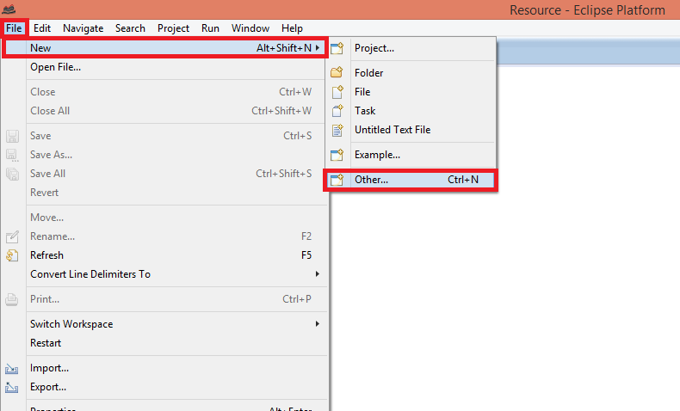
Choose a “Modeling Project option”:
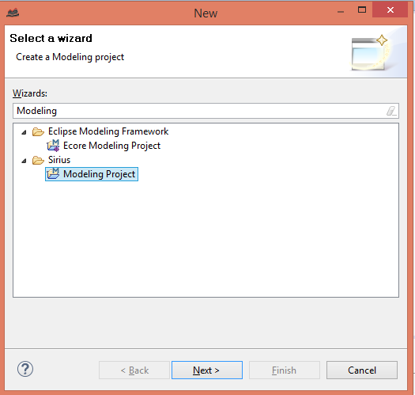
Insert a name for the Project and push “Finish”. Now, if you want create a BPMN diagram, you should follow the steps that the next image shows (Right click mouse over the name of the Project):
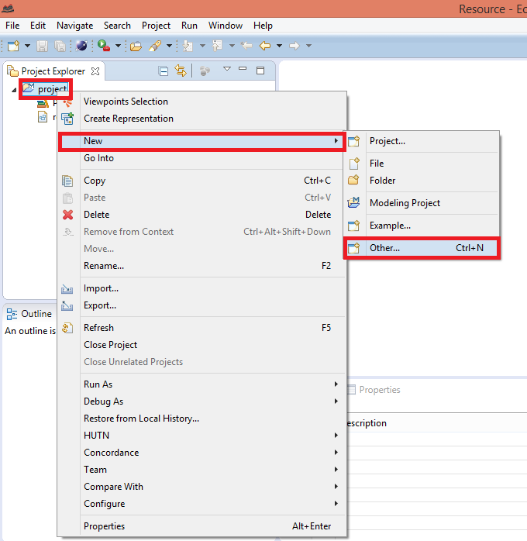
Insert “BPMN” into the Wizard’s box and choose the BPMN Model option:
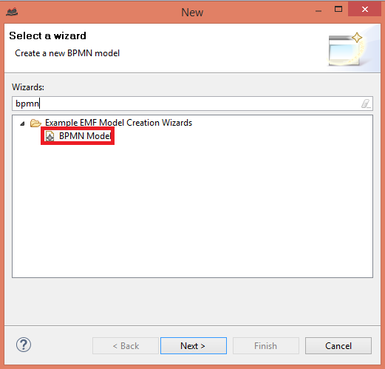
Later on, you should choose the element “BPMN” as root of the diagram. When you have finished, you should choose a BPMN viewpoint for select the graphical representation. To do this, right click mouse over the name of the Project and choose the option “Viewpoints selection”:
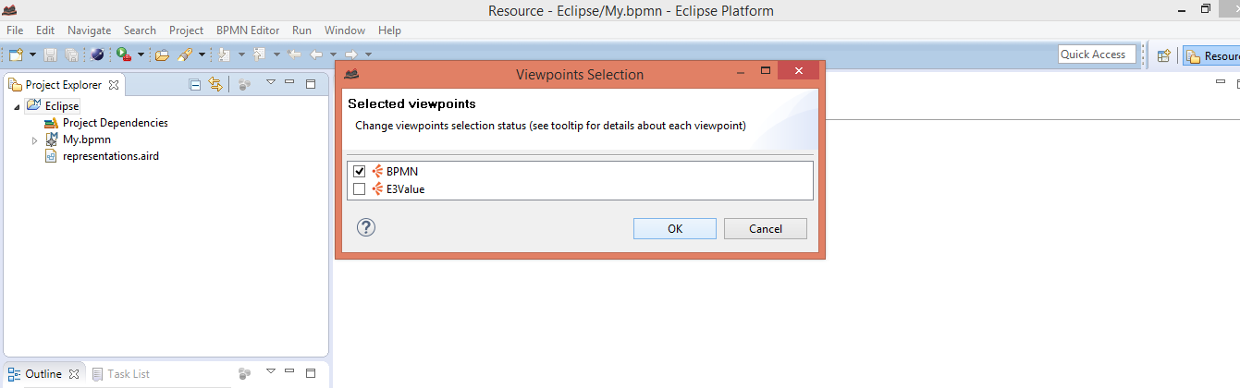
When you have finished this step, you only should choose a new BPMN representation for the BPMN model created. To do this, right click over the root of the model created and choose the option “New Representation”:
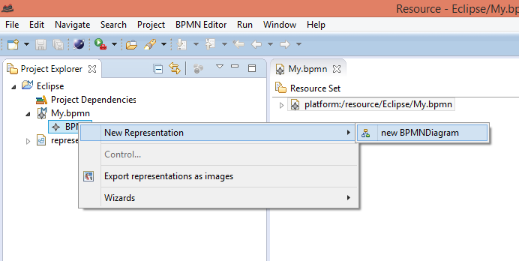

Create a E3Value:
Create a Modeling Project:
Choose a “Modeling Project option”:
Insert a name for the Project and push “Finish”. Now, if you want create a E3Value diagram, you should follow the steps that the next image shows (Right click mouse over the name of the Project and follow the next secuence “Next”> “Other”):
Insert “E3Value” into the Wizard’s box and choose the second E3Value Model option:
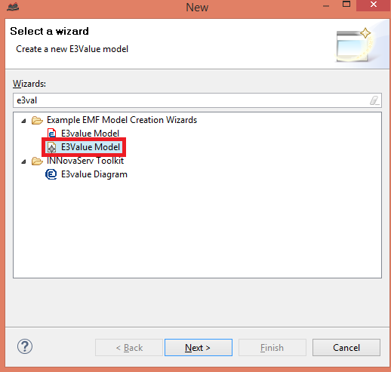
Later on, you should choose the element “Diagram” as root of the diagram. When you have finished, you should choose a E3Value viewpoint for select the graphical representation. To do this, right click mouse over the name of the Project and choose the option “Viewpoints selection”:
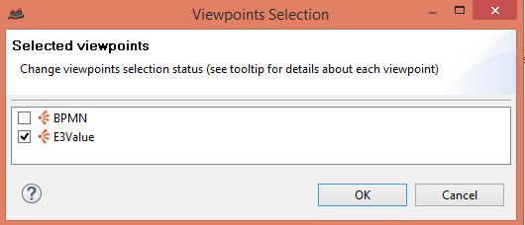
When you have finished this step, you only should choose a new BPMN representation for the BPMN model created. To do this, right click over the root of the model created and choose the option “New Representation”:
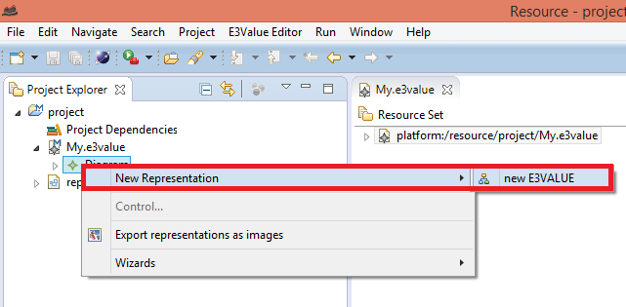

Create a PCN Diagram:
Create a Modeling Project (“File”> “New”> “Other”> “Modeling Project”) and choose a name for the Project. Later on, right click mouse over the name of the Project and choose the option “Example” for choose the option “Pcn Diagram”:
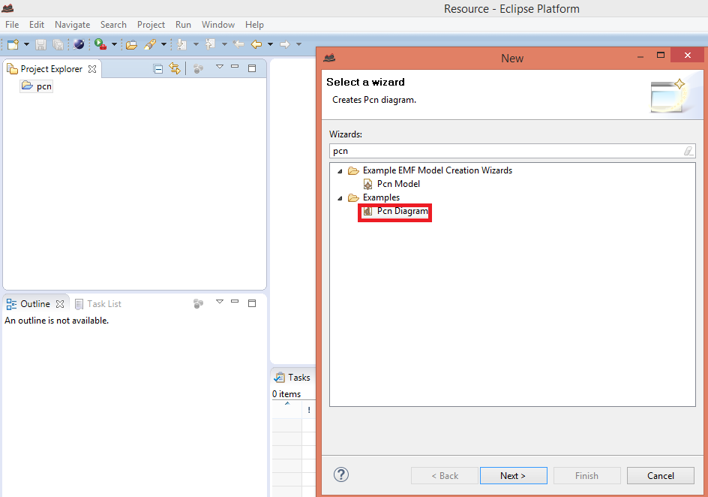

Create a Canvas Diagram:
Create a Modeling Project (“File”> “New”> “Other”> “Modeling Project”) and choose a name for the Project. Later on, right click mouse over the name of the Project and choose the option “Example” for choose the option “Canvas Diagram”:
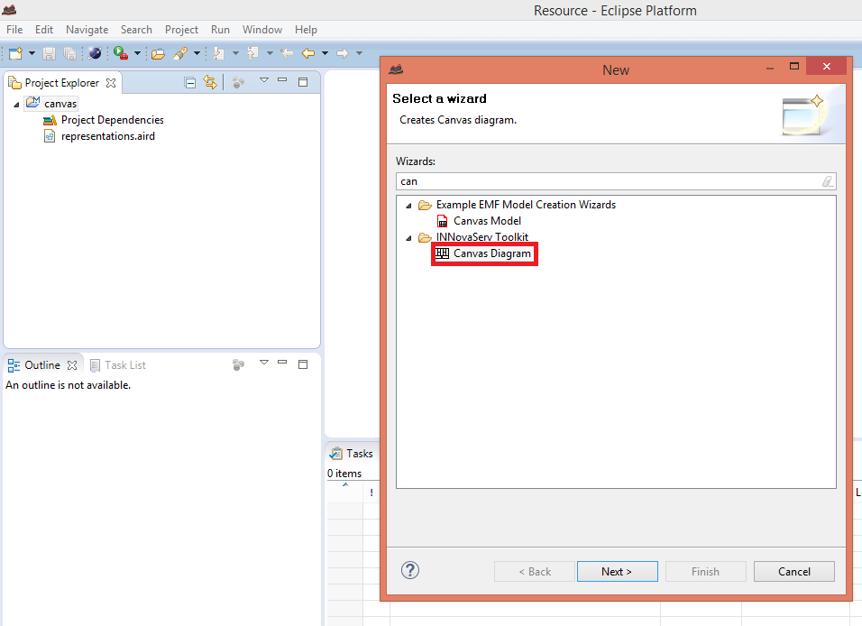

Create a ServiceBlueprint Diagram:
Create a Modeling Project ( “File”> “New”> “Other”> “Modeling Project”) and choose a name for the Project. Later on, right click mouse over the name of the Project and choose the option “Example” for choose the option “Serviceblueprint Diagram”:
